Text S1
Supplemental Material and Methods for:
Srf1 is a novel regulator of Phospholipase D activity and is essential to buffer the toxic effects of C16:0 Platelet Activating Factor.

NOTE for this document and Table S1:
L-PAF = 40 μM C16:0 lyso-PAF
PAF = 40 μM C16:0 PAF

Growth curves. Liquid growth curves were obtained from 24 plates and each curve consisted of 45 OD₆₀₀ readings taken at intervals of 25 minutes. On each plate, 6 strains were examined (wild type plus 5 others) and each strain was represented in 9 independent wells (3 replicates of the 3 treatments: ethanol, L-PAF, and PAF). There were potentially 24 * 6 = 144 groups of 9 growth curves, but 4 groups were excluded because they were irrelevant strains, e.g. diploids, or because the deleted ORF is now regarded as dubious in SGD. Among the remaining 140 growth curve groups, it was possible to study 140 – 24 = 116 non wild type strains. However only 90 unique haploid deletion mutants were studied, as some strains were studied on multiple plates.

Summary of Liquid Growth Curve Analysis
# strains | # plates on which strain was studied | notes
66 | 1
22 | 2
2 | 3 | FEN1  YIL012W
 | 66 + 22*2 + 2*3 = 116 non wild type groups of growth curves
1 | 24 | Wild type
 | 116 + 24 = 140 groups of growth curves
91 | Total strains studied

In principle, there should have been 140 * 9 = 1260 growth curves available for analysis. However, there were 13 missing growth curves and, therefore, 1247 growth curves available for analysis. The 13 missing curves map back to 10 growth curve groups, but in each group there was always at least two usable growth curves for each of the 3 treatments.

# of growth curve groups | # of missing curves (out of 3 * 3 = 9) | # of usable curves (out of 9) | notes
130 | 0 | 9
8 | 1 | 8
1 | 2 | 7 | BNA1 d11 missing 1 eth curve and 1 L-PAF curve
1 | 3 | 6 | RNR3 d8 missing 1 curve from each treatment
140 | Total groups | (130 * 9) + (8 * 8) + 7 + 6 = 1247 | Total usable growth curves

Logistic Growth Curve Analysis (LGCA). A four-parameter logistic growth model was fit to the growth curves [1]:

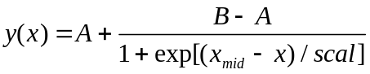
where x is time and y is the OD reading, a proxy for cell density or population size. A is the starting point of growth or minimum OD reading, B is the carrying capacity or maximum OD reading, x_{mid} is the time at 50% of total growth, and scal is approximately the time taken to go from 50 to 75% of growth.

To simultaneously account for the repeated measurement of individual wells and for the systematic effects of treatment and gene deletion on growth, we fit a mixed effects logistic growth model using the R package nlme [2,3] (R code available upon request). The model was fit to the ensemble of 54 curves obtained for each plate separately. Each of the four growth parameters (A, B, x_{mid}, scal) could therefore be modeled with a combination of fixed gene deletion and/or treatment effects and random well effects and this table summarizes our approach:

parameter | How treated in mixed effects logistic model
A | Fixed effect, one common value across entire plate.
B | Fixed effect. In most cases, one value for each strain. For a few slow-growing strains, the carrying capacity was assumed to be that of wild type.
x_{mid} | Fixed and random effects.  Fixed effects: x_{mid} ~ t * g  Random effect: random intercept for each growth curve (or well)
scal | Fixed and random effects.  Fixed effects: scal ~ t * g  Random effect: random intercept for each growth curve (or well)

To identify chemical-genetic interactions, we focused on the x_{mid} parameter. From the fitted model, we combined fixed effect estimates and predicted random well effects to produce a value of x_{mid} for each growth curve, which was treated as derived data for downstream analysis.

Inter-plate normalization
There was evidence of non-negligible plate effects as well as interaction effects between plates and the treatments L-PAF and PAF, indicating the need for inter-plate normalization. Due to the inclusion of wild type replicates on all plates for all 3 treatments, a normalization model could be fit to the wild type x_{mid} values to obtain estimates of plate and plate-by-treatment interaction effects:
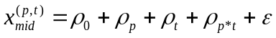
where 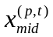is a wild type x_{mid} value for plate p and treatment t. The intercept ρ₀ is the expected value of a wild type x_{mid} under the reference treatment (ethanol) when assayed on a designated reference plate, ρ_{p} is the effect associated with a non-reference plate p, ρ_{t} is the effect of treatment t (either L-PAF or PAF) on the reference plate, and ρ_{p*t} is an interaction effect for the combination of plate p and treatment t. The nuisance parameters ρ_{p} and ρ_{p*t} represent experimental artifacts associated with plate-to-plate variation and, once estimated, are used to normalize all the observed values of x_{mid}, for deletion mutants as well as wild-type, like so:

******
******
Ideally the normalized x_{mid} values now reflect the x_{mid} values that would have been observed, if the experimental conditions of the reference plate had been held perfectly constant across all plates. The concordance of the wild type xmids across all 24 plates indicates that the normalization strategy worked very well.

Interaction analysis
After normalization, we fit the following model for x_{mid}:
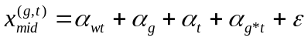
where 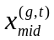is the estimated/predicted and normalized value of x_{mid} for one growth curve, corresponding to the deletion of gene g and the treatment t. The typical x_{mid} for wild type in the ethanol reference condition is given by α_{wt} and α_{g} and α_{t} are the individual effects, respectively, of deleting gene g or of treatment t (see Model below). The primary parameter of interest is α_{g*t} which captures the interaction between deletion g and treatment t. Mutants deemed hypersensitive to a single PAF species were identified based on tests of the null hypotheses that α_{g*L-PAF} = 0 or α_{g*PAF} = 0. Mutants deemed differentially sensitive were identified based on a test of the null hypothesis that α_{g*PAF} - α_{g*L-PAF} = 0. There are 90 potential gene deletions g and 3 parameters of interest (α_{g*L-PAF}, α_{g*PAF}, α_{g*PAF} - α_{g*L-PAF}), for a total of 270 tests. We did a global Bonferroni correction, i.e. multiplied p-values by 270, and threshholded at 0.04 to obtain hits (5 L-PAF hypersensitives, 10 PAF hypersensitives, 11 PAF vs. L-PAF differentially sensitives).

Interaction Model:
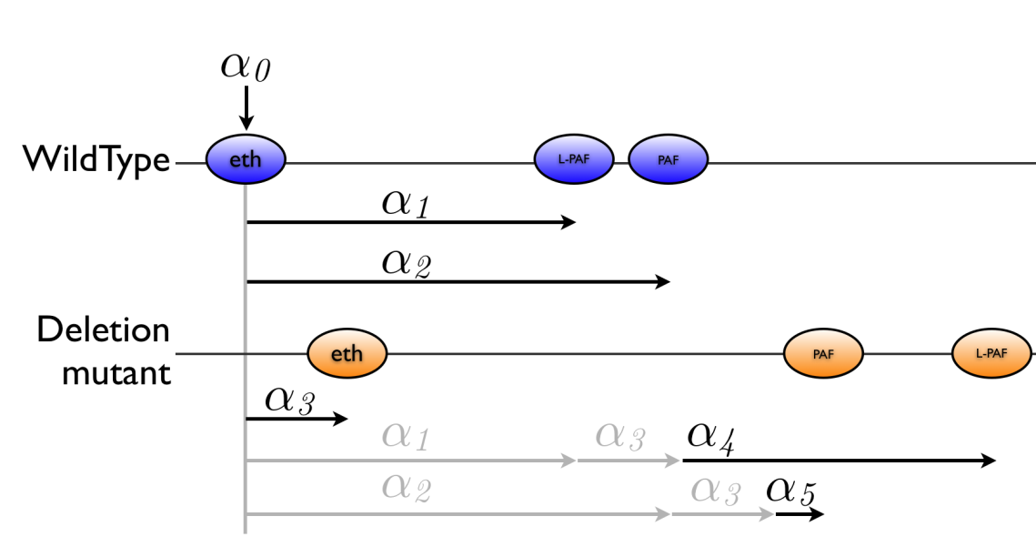

Parameter | Meaning
α₀ | Expected baseline x_{mid} , i.e. when WildType grows in ethanol.
α₁ | Effect of L-PAF on WildType.
α₂ | Effect of PAF on WildType.
α₃ | Effect of deleting ORF <?> when treatment = ethanol.
α₄ | Interaction effect of the deletion and L-PAF.
α₅ | Interaction effect of the deletion and PAF.

Strain/Treatment | Ethanol | L-PAF | PAF
WildType | α₀ | α₀ +α₁ | α₀ +α₂
<delMut> | α₀ +α₃ | α₀ +α₁ +α₃ +α₄ | α₀ +α₂ +α₃ +α₅

References:
1. Pinheiro JC, Bates DM (2000) Mixed Effects Models in S and S-Plus: Springer.
2. Pinheiro J, Bates D, DebRoy S, Sarkar D, team RC (2008) nlme: Linear and Nonlinear Mixed Effects Models. R package version 3.1-90 ed.
3. R Development Core Team (2008) R: A Language and Environment for Statistical Computing. Vienna, Austria: R Foundation for Statistical Computing.

